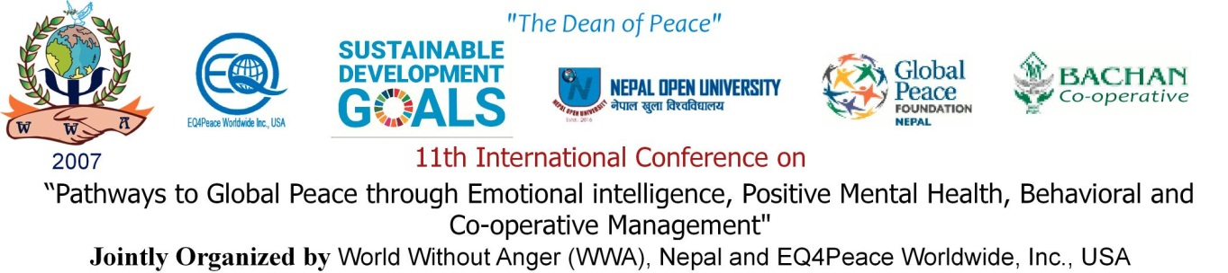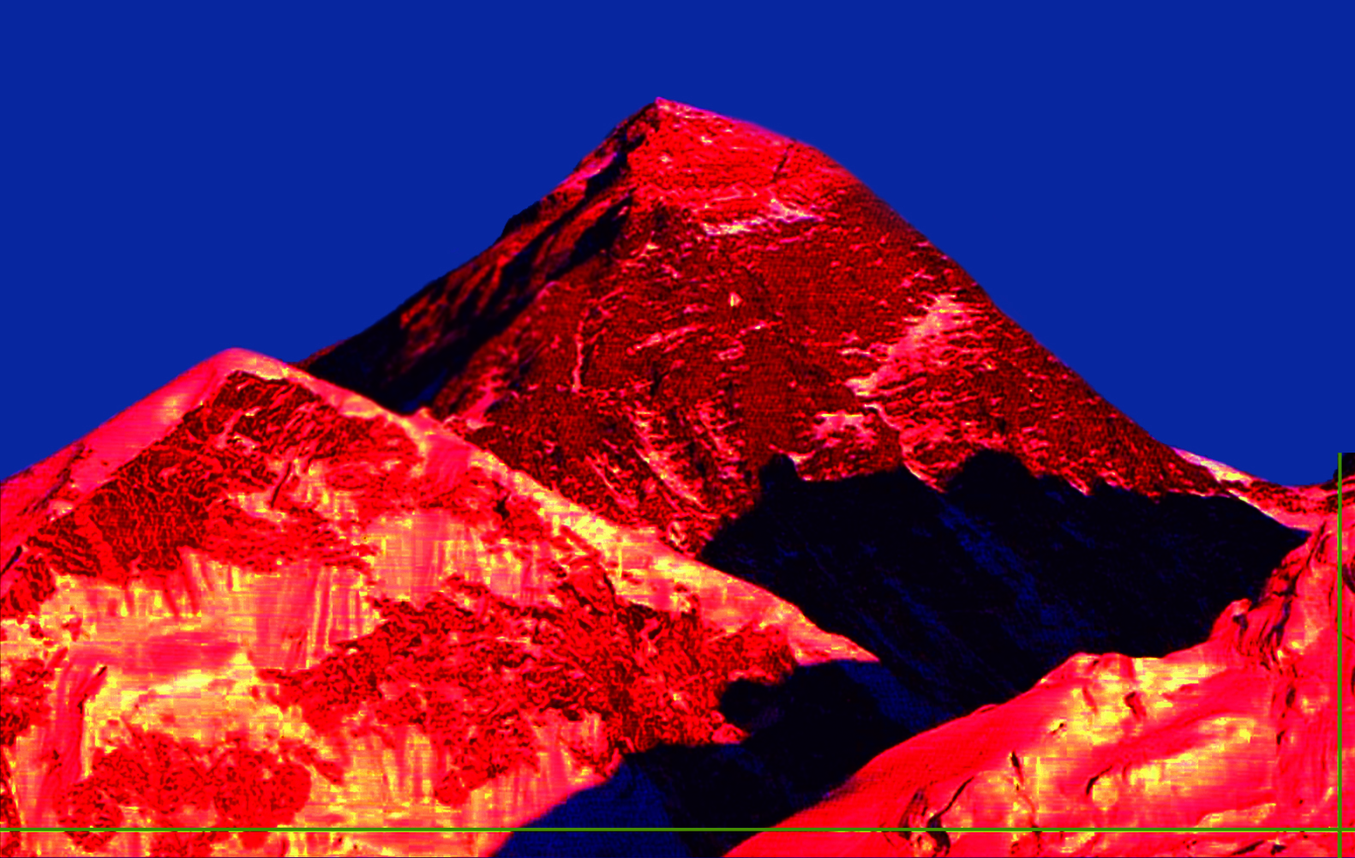

Mt. Everest

***Call for Papers***

The WWA international conference has gained world-wide recognition for its contribution to peace education, emotional intelligence, mental health, people management & cooperative researches. For the forthcoming conference of 11th International conference to be held on 21th to 22th September 2024 on the auspicious occasion of the ***United Nations International Day of Peace*** in Kathmandu, we solicit and invite research papers, review and conceptual papers, and case studies as well as concise thematic posters. The papers and posters should relate to the theme and sub-themes that include, but are not limited to:

1. Emotional Intelligence and Global Peace
2. Behavioral Management
3. Positive Mental Health
4. Cooperative Management
5. Buddhism and Peace

**11th WWA international conference**

Researchers and practitioners are solicited and invited to join this international platform that offers a tremendous opportunity to discuss, share and publish study findings and insights in the thematic areas. We look forward to meeting and interacting with scholars, researchers, practitioners, and policymakers from around the world in beautiful, historic capital city Kathmandu of Nepal.

**Submission guidelines**

Papers and presentations must be in English. An abstract must be within 250 words, and full paper within 3000 words. The participants of all authors should be submitted to:

**Dr. Anoop Shresthacharya,**

Conference Coordinator

CEO, WWA / Professional Economics Consultant

Email: wwa2024conference@gmail.com

Website: <https://www.worldwithoutanger.org/>

Phone Number : 977-014534320, 4535779

Mobile Number: 977-9841278935

Conference Venue: Kathmandu, Nepal

**Important Dates**

21st August 2024 Deadline for submitting abstracts.

28th August 2024 Notification of acceptance

6th September 2024 Deadline for submitting full papers.

18th September 2024 Deadline for submitting PPTs/Slides

20thSeptember 2024 Registration deadline

21stto 22ndSeptember 2024 **Conference date**

**11th WWA International Conference Organizers**

International Scientific Committee Chairperson

**Prof. Dr. Murari P. Regmi**

Dept. of Psychiatry & Mental Health, Tribhuvan University

*International Advisory Committee Chair*

# **Mr. Dipak Prakash Baskota**

Former Executive Chairman of the National Cooperative Federation of Nepal and First Chair of the National Cooperative Development Board, Govt. of Nepal

*International Chief Patron*

**Prof. Matt Perelstein**

Founder/President

EQ4Peace Worldwide Inc., USA

*Conference Chair*

**Prof. Dr. Arhan Sthapit**

Dean, Faculty of Management and Law, Nepal Open University(NOU)

*Organizing Secretary*

**Dess Mardan Basnet, Ph.D.**

Founder/President, World Without Anger (WWA)

*Convener*

**Asst. Prof. Sandesh Dhakal, Research Scholar**

Central Department of Psychology, Tribhuvan University

*Co-convener*

**Dr. Dola Mujumder**

Vivekananda College for Women, University of Calcutta., India